Error Handling Helpline
Group Members
- Reece Willoughby
- Alexi Colley
- Nawaraj Budhathoki
- Roman Reshetniak
GitHub: reece
https://github.com/WILR96/ErrorHandlingHelpline
Task board: reece
https://github.com/users/WILR96/projects/1
Project Idea Summary Reece
This project is a debugging and programming help platform that enables students to share technical problems and receive support from the community. Users can post error messages, code snippets, and environment-related issues, while others can respond with explanations and debugging guidance.
The platform aims to encourage collaborative learning, peer support, and the development of problem-solving and critical thinking skills.

Core User Stories
Create Help Post
As a user, I want to create a help request, so that I can receive assistance with a coding problem.
Acceptance Criteria:
- User must be logged in.
- User can add title and description.
- Optional code/image upload.
- Post appears in main feed with any files added.
View Posts
As a user, I want to browse help posts, so that I can find problems I can assist with.
Acceptance Criteria:
- All posts are displayed in the main feed.
- Each post shows title, author and timestamp.
- Posts are ordered by most recent by default.
Answer a Post
As a user, I want to respond to a help request, so that I can assist another student.
Acceptance Criteria:
- User must be logged in.
- User can submit a written response.
- Response appears under the original post.
- Response shows author and timestamp.
Mark Answer as Solved
As the original poster, I want to mark an answer as solved, so that helpful responses are recognised.
Acceptance Criteria:
- Only the original poster can mark an answer as solved.
- Only one answer can be marked as solved.
- Solved answer is visually highlighted.
- Reputation points are awarded to the responder.
Mark Answer as Helpful
As a user, I want to mark an answer as helpful, so that quality contributions are rewarded.
Acceptance Criteria:
- User must be logged in.
- A user can only mark an answer helpful once.
- Helpful count updates immediately.
- Reputation points are awarded to the responder.

Gamification User Stories
Earn Reputation
As a contributor, I want to earn reputation points when my answers are marked as solved or helpful, so that my contributions are recognised.
Acceptance Criteria:
- Reputation increases when answer is marked solved.
- Reputation increases when answer is marked helpful.
- Reputation cannot exceed daily cap.
- Updated reputation is reflected immediately on profile.
View Reputation
As a user, I want to see my reputation score and role title, so that I can understand my standing within the community.
Acceptance Criteria:
- Reputation score is visible on user profile
- Role title is displayed based on reputation
- Role updates automatically when threshold is reached
Automatic Role Progression
As a contributor, I want my role (e.g., Contributor, Trusted Helper, Community Mentor) to update automatically based on my reputation, so that mentorship emerges naturally.
Acceptance Criteria:
- The system assigns a role based on predefined reputation thresholds
- Role updates automatically when a user reaches a new threshold
- Role changes do not require manual approval
- The updated role is displayed immediately on the user’s profile
- The updated role is displayed next to the user’s username in posts
- Role cannot be manually edited by the user
View Other Users’ Reputation
As a user, I want to see reputation and role titles next to usernames in posts, so that I can identify experienced contributors.
Acceptance Criteria:
- Role title is displayed next to username
- Reputation score is displayed next to username
- Display updates automatically when reputation changes
Earn Badges
As a user, I want to earn badges for milestones (e.g., first solved answer), so that positive behaviour is encouraged.
Acceptance Criteria:
- Badge is awarded when milestone is reached
- Badge is visible on user profile
- Badge remains permanently once earned
Private Messaging
As a user, I want to be able to message other users privately for help, so that I can receive more detailed guidance outside of a public thread.
Acceptance Criteria:
- User must be logged in to send or receive messages.
- User can send a private message to another registered user.
- Recipient receives a notification of a new message.
- Messages are only visible to the sender and recipient.
- Message history is stored and viewable within a conversation thread.
- Users cannot message themselves.
- Users can report or block inappropriate messages.

Moderation User Stories
Report Content
As a user, I want to report inappropriate or low-quality content, so that the community remains supportive and safe.
Acceptance Criteria:
- Report button is visible on posts and answers
- User must be logged in to report
- Report is recorded in the system
- Administrator can review reported content
Daily Reputation Cap
As a system administrator, I want to limit daily reputation gain, so that users cannot exploit the scoring system.
Acceptance Criteria:
- The system defines a maximum amount of reputation that can be earned per user per 24-hour period
- Reputation points stop increasing once the daily cap is reached
- The cap resets automatically after 24 hours
- Users cannot bypass the cap through multiple posts or repeated interactions
- The system still records helpful or solved actions even if no additional reputation is awarded
- The cap value can be configured by an administrator
Delete Posts
As a system administrator, I want to delete inappropriate or low-quality posts, so that the community remains safe, respectful, and supportive.
Acceptance Criteria:
- Administrator must be logged in with admin privileges.
- Administrator can delete any post from the system.
- Deleted posts are removed from the public feed.
- Associated answers/comments are also removed or handled appropriately.
- The system records that the post was deleted.

Use Case Diagram
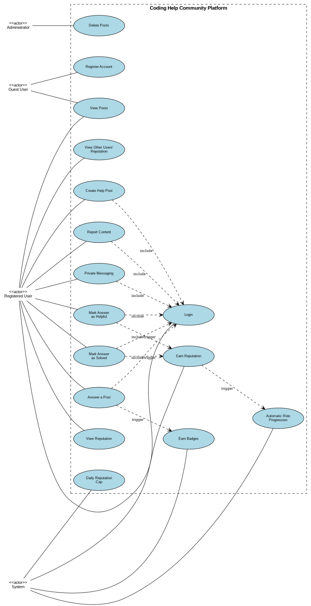

Overview
This diagram outlines the key actors, use cases, and automated system behaviours for the Coding Help Community Platform — an error handling helpline where junior developers seek help and experienced engineers provide guidance.
Actor
Actor | Key Capabilities
Guest User | Register account | View posts (read-only)
Registered User | Login | Create help post | Answer posts | Mark as solved/helpful | View reputation | Private messaging | Report content
Administrator | Delete posts | Review reported content | Configure system settings
System | Auto-calculate reputation | Role progression | Award badges | Enforce daily reputation cap
Use Cases

# | Use Case | Category
1 | Register Account | Authentication
2 | Login | Authentication
3 | Create Help Post | Content Management
4 | View Posts | Content Management
5 | Answer a Post | Content Management
6 | Mark Answer as Solved | Content Management
7 | Mark Answer as Helpful | Content Management
8 | Earn Reputation | Gamification
9 | View Reputation | Gamification
10 | Automatic Role Progression | Gamification
11 | Earn Badges | Gamification
12 | Private Messaging | Communication
13 | Report Content | Moderation
14 | Delete Posts | Moderation
15 | Daily Reputation Cap | Moderation

Key Relationships

Include  (Login required) | Create Post | Answer Post | Mark Solved | Mark Helpful | Private Messaging | Report Content
Triggers  (automated) | Mark Solved -> Earn Reputation -> Role Progression | Answer Post -> Earn Badges

Reputation & Role Progression

Solved answer | +10 points
Helpful answer | +5 points
Daily cap | Max 100 points per day (resets every 24 hrs)
Contributor | 0 - 99 points
Trusted Helper | 100 - 499 points
Community Mentor | 500+ points

User Flow Examples

New User | Register -> Login -> View Posts -> Answer Post -> System awards Reputation & 'First Answer' badge
Posting a Problem | Login -> Create Help Post -> Community responds -> Mark Answer as Solved -> System awards Reputation & checks Role Progression
Moderation | User reports content -> Admin reviews -> Admin deletes post if violation confirmed

Implementation Notes

- All authenticated actions must verify user session/token.
- Reputation, badges, and role updates should run asynchronously to avoid blocking.
- Reputation calculations must be atomic to prevent race conditions.
- Rate-limit Report Content to prevent abuse.
- All admin actions should be logged for audit trail.

Wireframes
Archive Category's Tickets
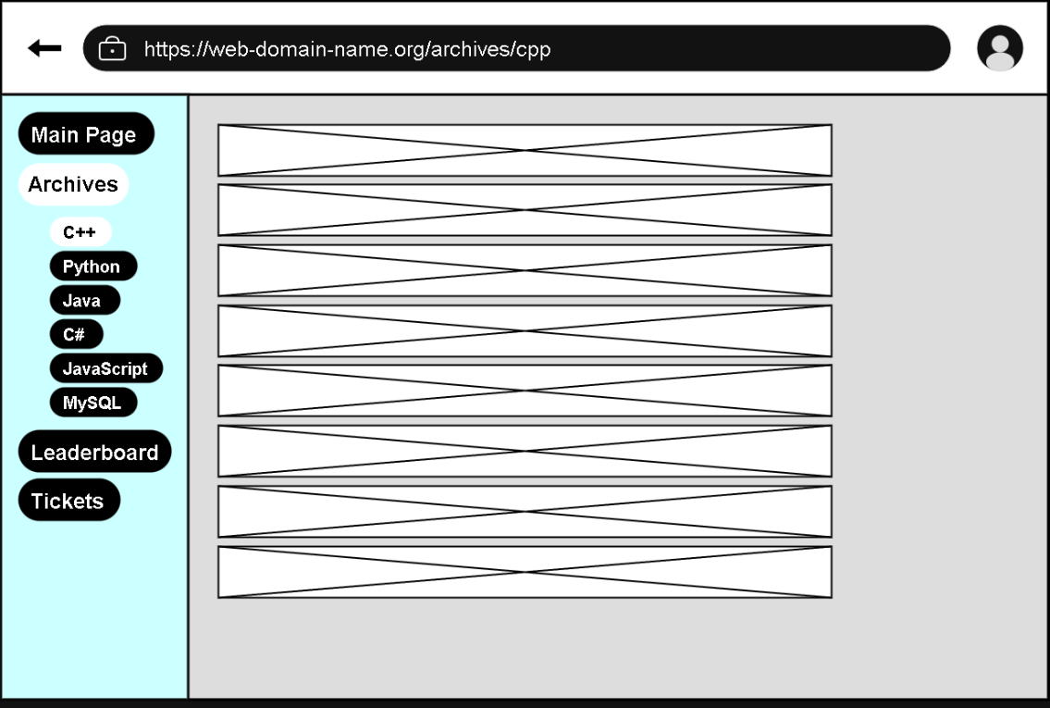

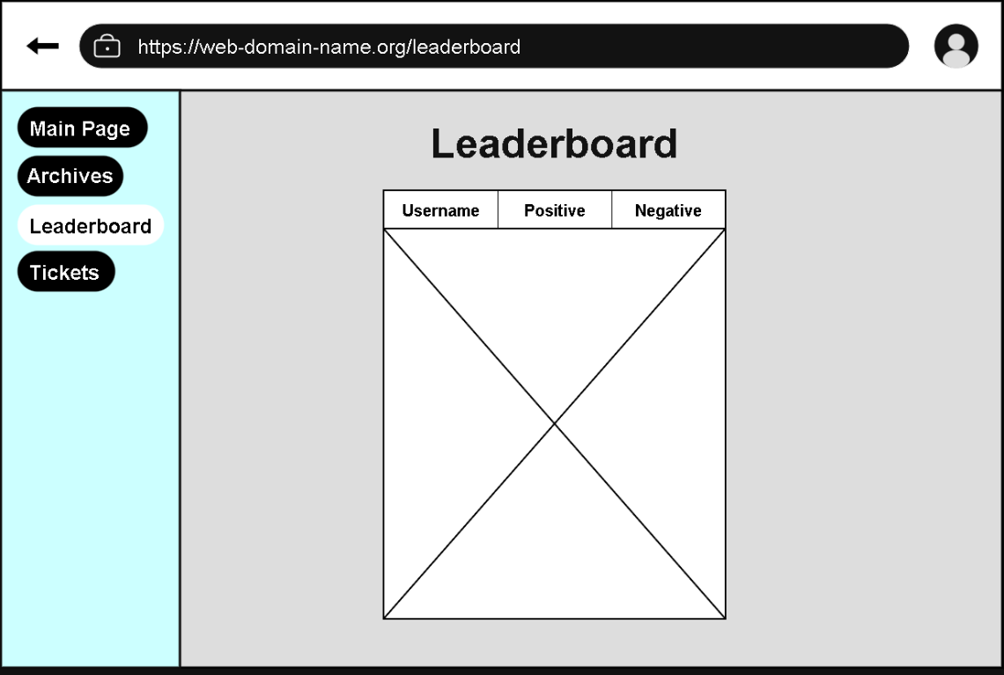
Leaderboard

Login
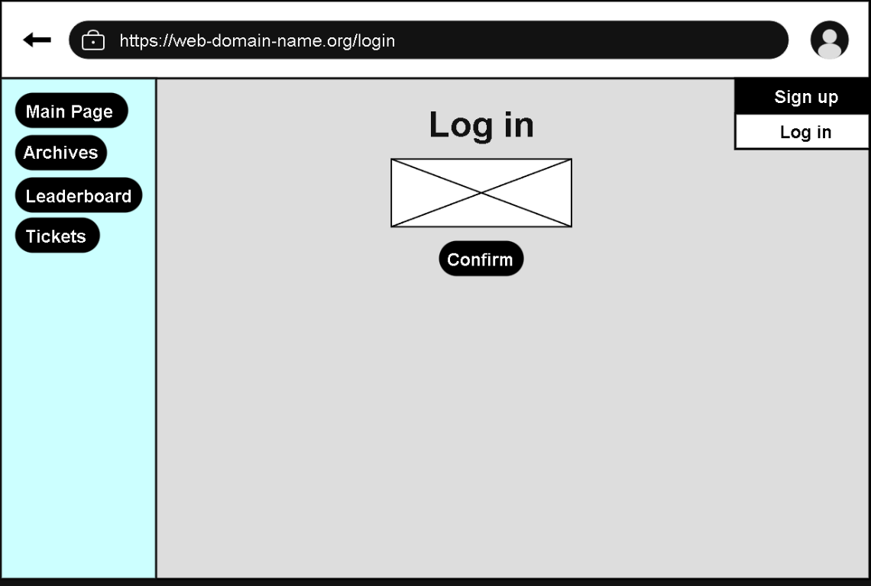

Main Page
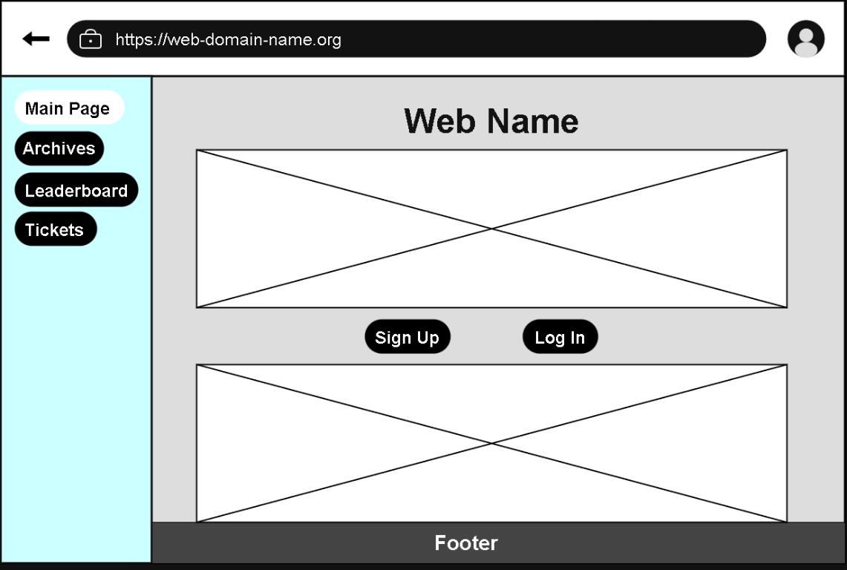

Ticket Booking
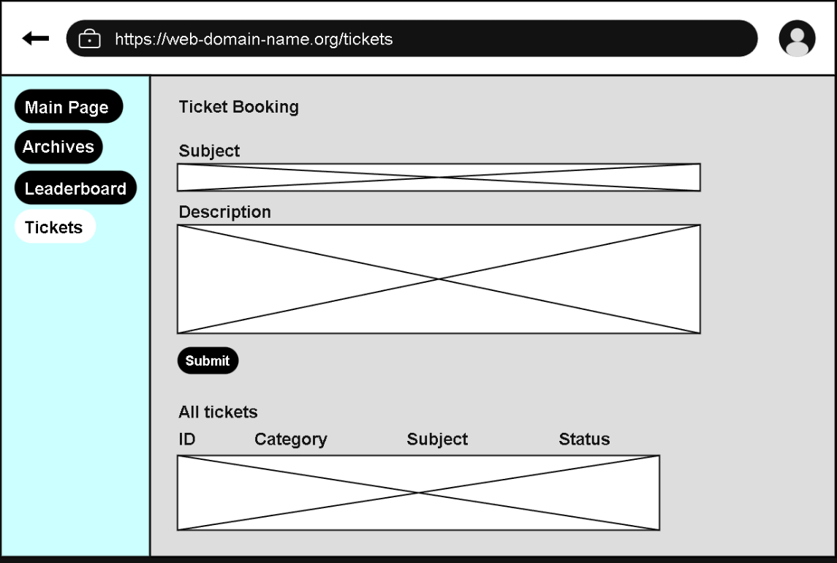

Sign up
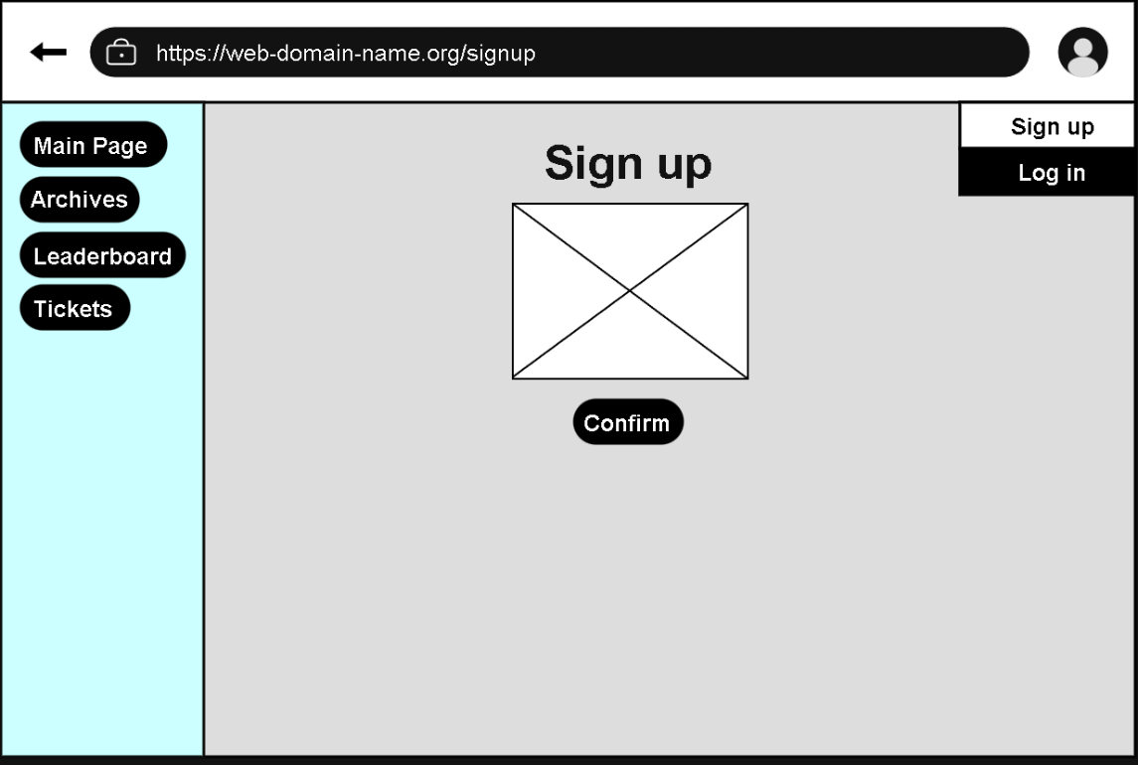

Ticket Interface
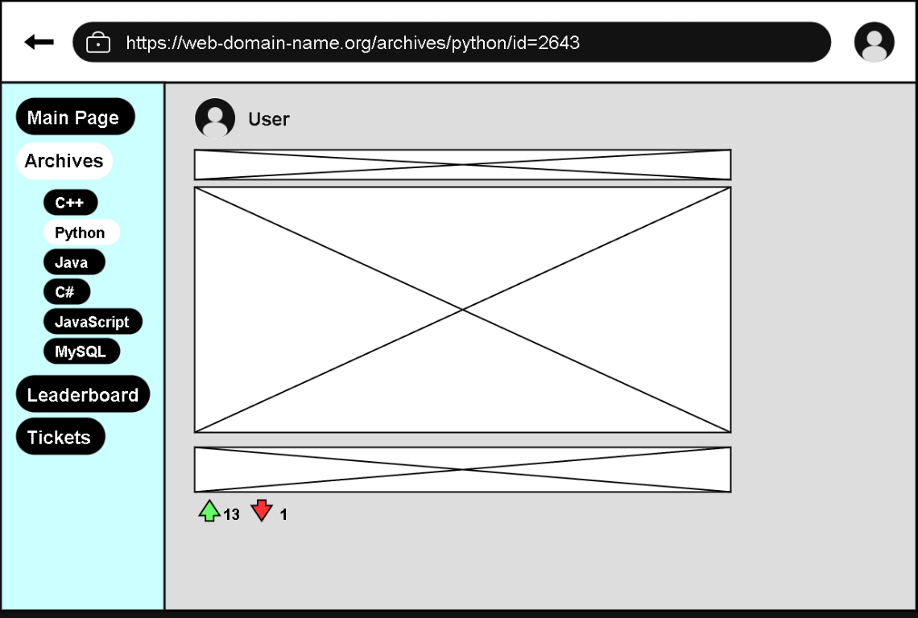

Activity Diagrams
Create a Ticket (Post) Comment on a Ticket
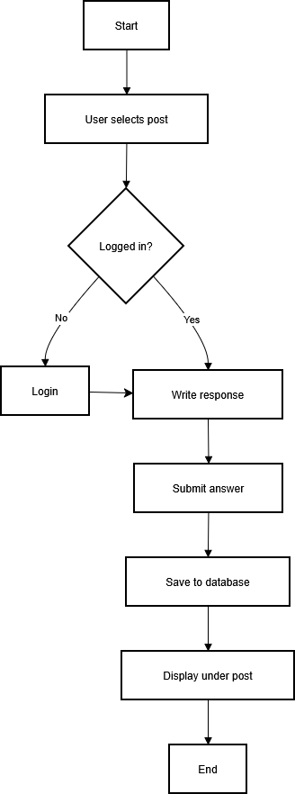
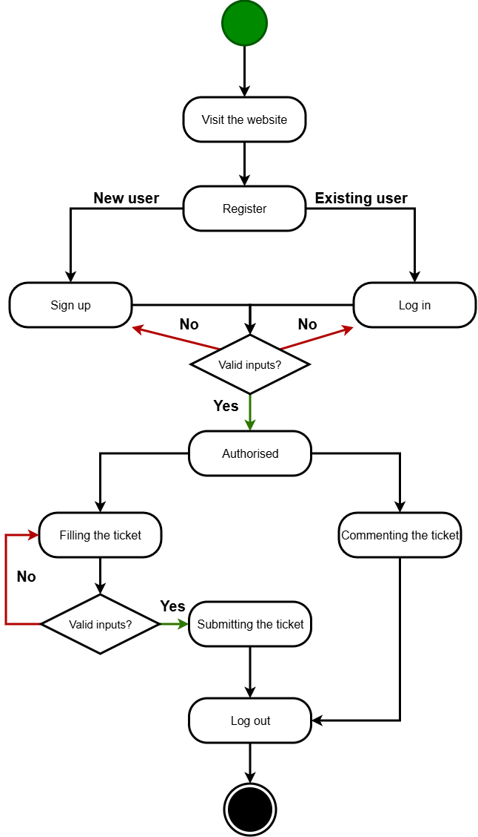

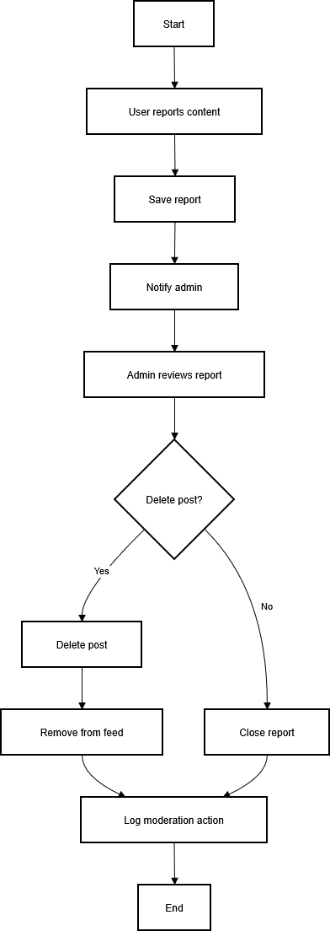
Report content Reputation system
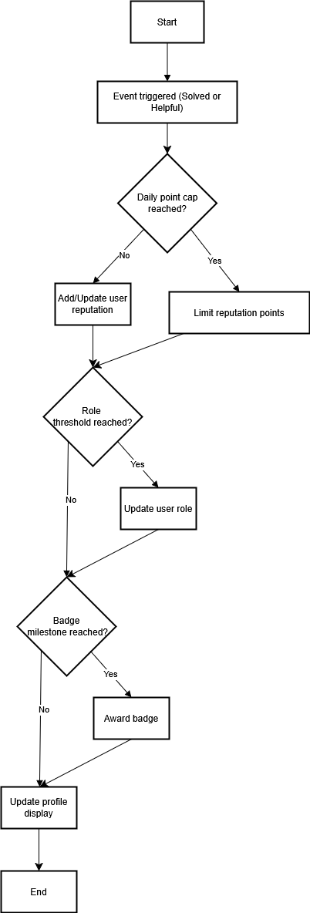

Mark as solved
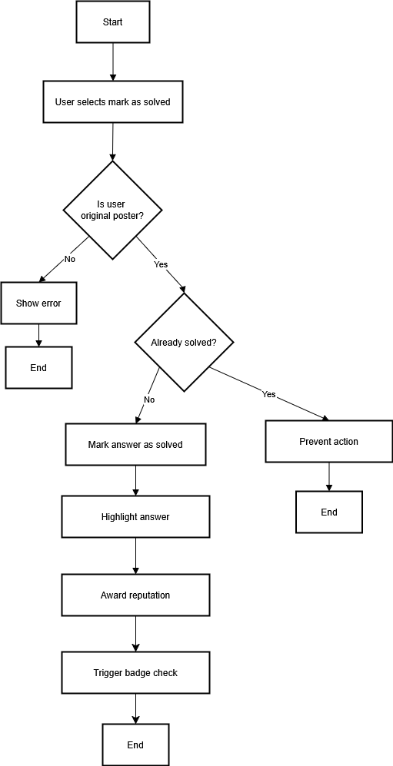

Kanban board
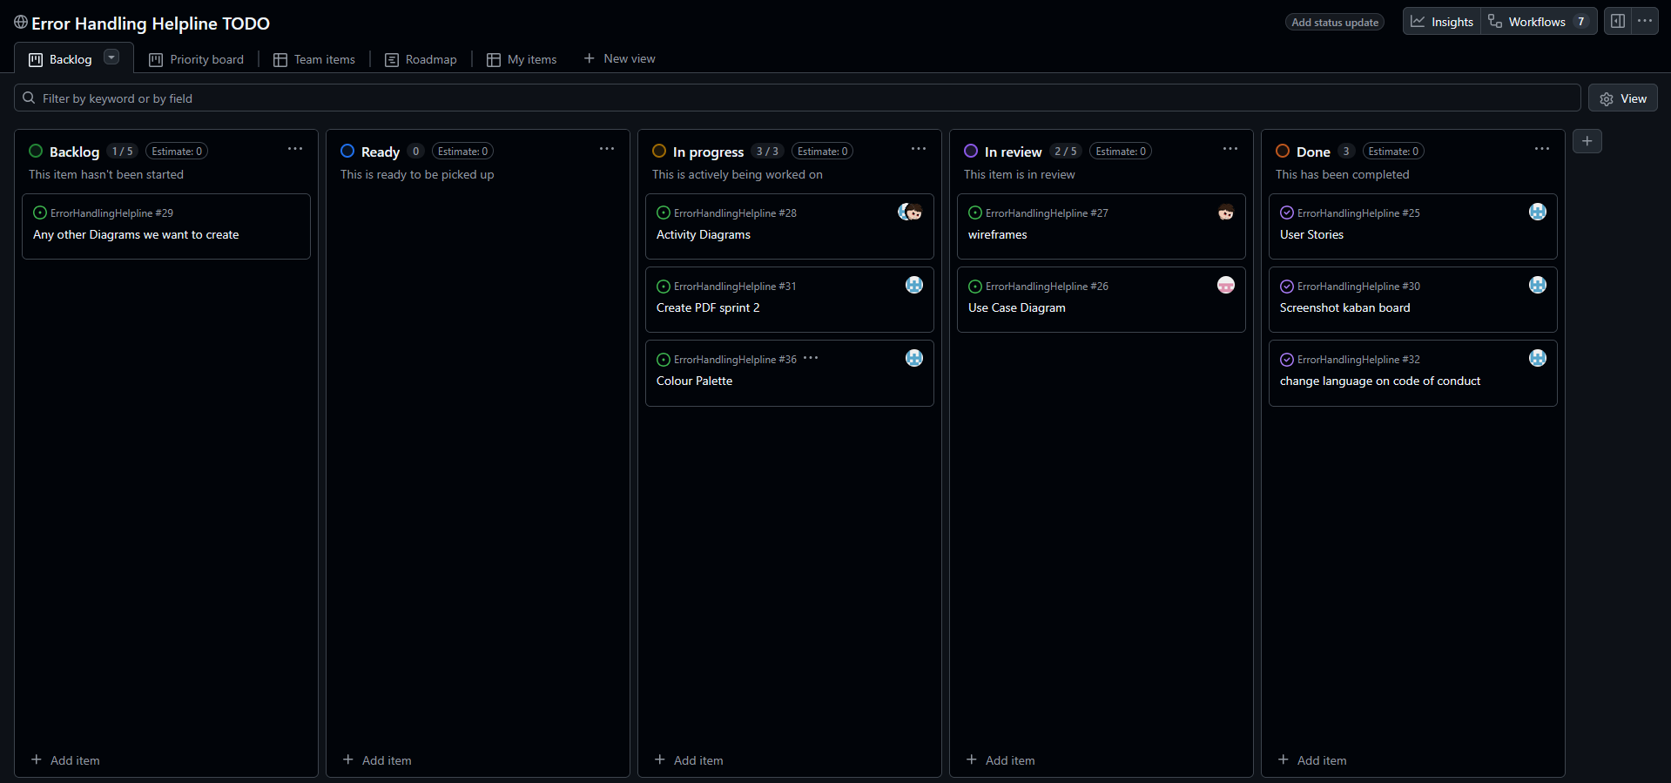

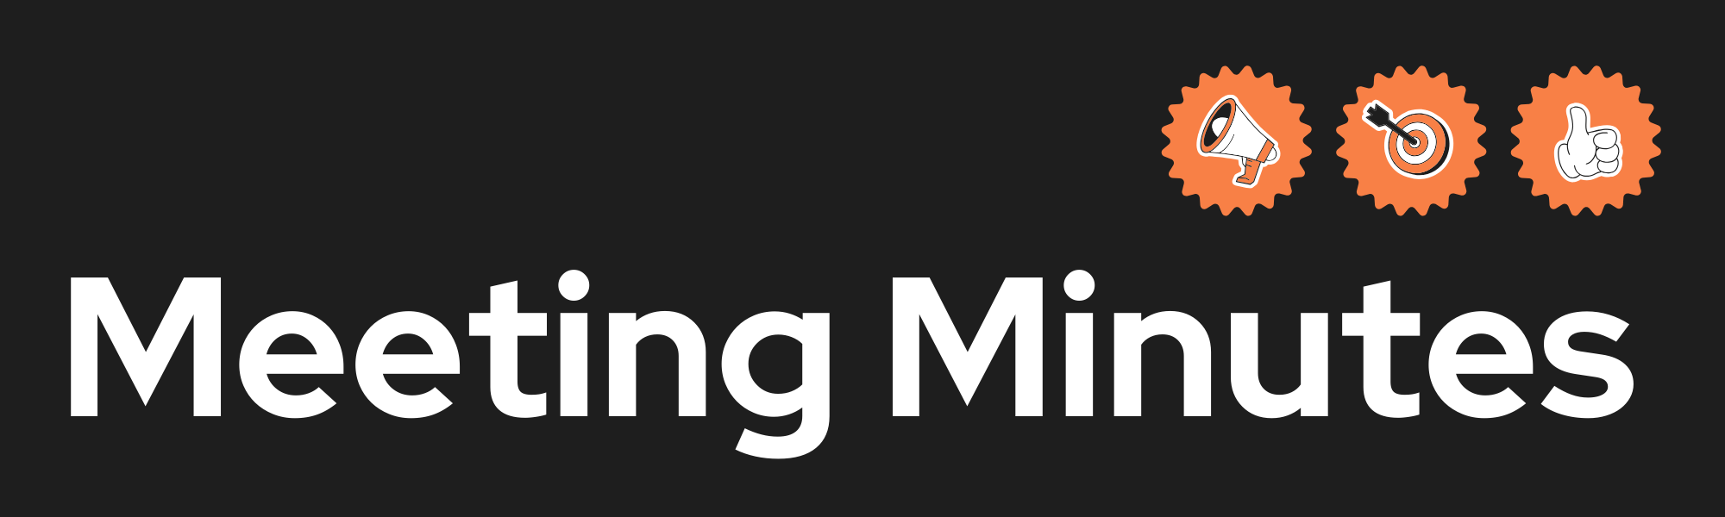
Date and Time | 10/02/2026
Project Name | Error Handling Helpline
Meeting Goal | - Define some new features that relate to the coursework brief  - Assign jobs for sprint 2
Facilitator | Reece Willoughby
Note taker | Reece Willoughby
Attendees | Reece Willoughby  Alexi Colley  Nawaraj Budhathoki
Roundtable Updates (each group member to contribute) | Reece suggested that we talk about the different features we should have in the project.
Discussion points | Social messaging  Time trials – for error handling  Liking things (like comments)  Give awards to smart comments.  Give variable points to users when commenting  Upload images / programming files  Leaderboards – Special rewards for top 10
Actions (list tasks and assign a group member) | Distributed all tasks.

